**BUKET NETWORK**

**A Project Based Learning PROJECT Report**

**for COMPUTER NETWORKS (SWE308)**

**of**

**Master of Science**

***in***

**Software Engnieering**

*by*

**P Vishnu Prasaath - 14MSE0025**

**Monicaa B- 14MSE0172**

**Sandhiya K- 14MSE**



**School Of Information Technology and Engineering**

November, 2016



**School Of Information Technology and Engineering**

**DECLARATION BY THE CANDIDATE**

I hereby declare that the thesis entitled **“BUCKET NETWORK”** submitted by me to Vellore Institute of Technology University Vellore, in partial fulfillment of the requirement for the award of the degree of **Master of Science** in **Software Engineering** is a record of bonafide project work carried out by me under the supervision of **Prof. Sudha S**.

**Place**: Vellore

**Date**: **Signature of the Candidate**



**School of Information Technology and Engineering**

**BONAFIDE CERTIFICATE**

This is to certify that the project work entitled “**BUCKET NETWORK”** by

**P.Vishnu Prasaath (14MSE0025), B.Monicaa (14MSE0172),** **K.Sandhiya (14MSE0000),** to Vellore Institute of Technology University, Vellore, in partial fulfillment of the requirement for the award of the degree of **Master of Science** in **Software Engineering**, is a project bonafide work carried out by him under supervision.

**Prof. Sudha S**

**Supervisor**

**Assistant Professor(Senior)**

**SITE**

**VIT University**

**Internal Examiner(s)**

**TABLE OF CONTENTS**

|  |  |  |
| --- | --- | --- |
| **CHAPTER NO.** | **TITLE** | **PAGE NO.** |
|  | **ABSTRACT** |  |
|  | **LIST OF FIGURES** |  |
|  | **LIST OF SYMBOLS** |  |
|  |  |  |
| 1. | **INTRODUCTION** |  |
|  | 1.1 Motivation |  |
|  | 1.2 Issues |  |
|  |  |  |
| 2. | **PROBLEM DEFINITION** |  |
|  | 2.1 Critical Issues |  |
|  | 2.1.1 |  |
|  | 2.5 Problem Definition |  |
|  |  |  |
| 3 | **PROJECT DESCRIPTION** |  |
|  | 3.1 List of Modules |  |
|  | 3.4 Requirements Specification |  |
|  | 3.4.1 Software Requirements |  |
|  | 3.4.2 Hardware Requirements |  |
|  | 3.5 Module Description |  |
| 4 | **IMPLEMENTATION OF PROJECT** |  |
|  | 4.1. Source code |  |
|  | 4.2 Snapshot/Screen shots of the project |  |
| 5 | **RESULTS AND DISCUSSIONS** |  |
| 6 | **CONCLUSION AND FUTURE WORK** |  |
|  | 6.1 Conclusion |  |
|  | 6.2 Future Work |  |
|  | **References** |  |

**ABSTRACT**

This project contains the implementation of file transfer from one machine to another machine in a LAN with a newly developed security algorithm based on IP address of the receiver. There are various levels of network security implemented in this Bucket Network.

Security is considered as an important issue in all the web applications. Especially in a wireless communication medium, there is an increased possibility of security threats. Though many new technologies have been developed to overcome all the problems, still hackers find a way to crack all the security levels. But its really challenging to safeguard the data from the hackers, who use all the loop holes in the system to gain access to the secure data.

Bucket Network builds a strong security system based on a newly developed Bucket algorithm which ensures high level of security in a LAN. Not all people can register, only users with and ACCESS CODE (provided with the administrator) can sign up. An important feature of this web app is that, all users are registered with their unique device IP address. This ensures that, the users account cannot be accessed from any foreign devices. Each user details are validated and saved in the database. The user passwords are saved using Bucket Algorithm which makes it secure and private. A captcha verification is added to prevent access by bots. Users can upload their files to the cloud and view all the files in the cloud based on the provided access. Thus Bucket Network guarantees high Security in terms data communication and file transfer.

Bucket network is completely developed in PHP 5.6. This is considered to one of the secure server side scripting language. The website is hosted in a LAN created by any technology (here we are using a mobile to create a LAN). MySQL database stores all the user data securely with the provided encryption technology. HTML and CSS are used in the front end development. PHP-mailer-master package has been incorporated to notify user activity via emails. The web application is compactible in all the devices (PC, Mobile and Tablet) and runs in all the Operating Systems.

**List of Figures**

|  |  |  |
| --- | --- | --- |
| **FIG. NO** | **TITLE** | **PAGE NO** |
| 1 | Symmetric Encryption |  |
| 2 | Asymmetric Encryption |  |
| 3 | Bucket Encryption |  |
| 4 | Bucket Decryption |  |

**LIST OF Abbreviations**

|  |  |
| --- | --- |
| **ACRONYM** | **EXPANSION** |
| **PC** | Personal Computer |
| **IDE** | Integrated Development Environment |
| **PHP** | Hypertext Pre-Processor |
| **HTML** | Hyper Text Mark up Language |
| **CSS** | Cascading Style Sheet |

**CHAPTER 1 – INTRODUCTION**

1. **INTRODUCTION**
   1. **Motivation**

In an Organization, it’s common to have an LAN with all the users and devices connected for effective communication and resource sharing. But there a lot of problems and issues linked with it. Security and privacy has always been a question in my mind. As my interest is towards Web Application development, I decided to develop a completely secure web application for sharing files securely. There are a lot of existing security algorithms which have been implemented in many places. I wanted to develop a new algorithm for imposing security in LAN. With a long research, I developed this “Bucket Cryption” algorithm.

* 1. **Issues**

Now a day's secure file sharing among different devices belonging to the same LAN is getting quite complicated. Certain Operating systems do not allow devices to share file with different Operating Systems. We have implemented “Bucket Network” application which helps the user to transfer files between any device, and any other device connected to the same wireless network. We have faced a lot of issues and challenges while developing this project. Sending a file of considerably big size have been a problem over wireless networks. The main aim of our project is to simplify the task of sharing files securely between different devices within a LAN. Transferring is rapidly growing in the field of technology as the capability of devices to store files is increasing. Overcoming all the issues we have succesfuly developed a Bucket Cryption Algorithm and implemented it in our system to impose high security and privacy.

**CHAPTER 2 – PROBLEM DEFINITION**

**2.1 Critical Issues**

**2.1.1 File transfer in android with small buffer**

All the android phones have limited buffer size. But a good application should have considerably large size buffer in order to store the data temporarily that comes from the sender end. All the smart phones have less memory capacity. Both RAM and ROM have less memory for utilization. These sizes are comparatively small when compared to computers.

**2.1.2 Session handling in file transfer**

Whenever the user logs in to the system form one device, the system must prevent the user from logging in from another simultaneously. This increases the risk factor. This is maintained through sessions.

**2.1.3 Send mail dynamically**

It is very effective feature of Bucket Network that the password key should be made to change dynamically after every login. It is also a challenge where the modified key should reflect on the database.

**2.1.4 Detect file path dynamically**

Whenever the desired file is selected, the path of that file should be detected dynamically from the file system. It is also a critical issue in the project. Because the path of the file can be determined depending upon the file system upon which the project is deployed. Android file system has a different levels of hierarchy, thereby making the file path determination more critical and complex to implement.

**2.2 Problem Definition**

The project should be able to transfer files between electronic gadgets. PC to PC and Android to PC data transfer. The user interface should be able to interact with users in easiest way, Bootstrap CSS should be neat and concise. There should not be any lag in performance in terms of metrics such as throughput and transfer speed.

**CHAPTER 3 – PROJECT DESCRIPTION**

**3. PROJECT DESCRIPTION**

This project is focused on building a secure web application for file sharing using the developed Bucket Cryption algorithm. The data is encrypted into a new form and stored in the database and this secured data is retrieved by the receiver by entering a secure key and accessing the site from their registered device.

**3.1 List of Modules**

* Register
* Login
* Encryption & Decryption
* Password Mailing
* File uploading and downloading

**3.2 Requirements Specification**

**3.2.1 Software Requirements**

* Operating System : Ubuntu 12 or above / Windows 7 or above
* Front end : HTML, CSS, Jquery
* Back end : PHP, SQLite
* Text Editor : Brackets
* Server : XAMPP
* Browser : Firefox, Chrome , Microsoft Edge

**3.2.2 Hardware Requirements**

* CPU speed : Pentium IV or above with 1.9GHz
* HDD : 40GB min
* Mouse type : Optical
* Keyboard type : 101 keys
* Monitor : min 15” VGA or above
* RAM : 2GB or above
* Network : Wifi of hotspot, wired Ethernet network

**3.3 Module description**

**3.3.1 Register**

A new user should first register with the Bucket network by providing valid username, password, name, mail id, school and access code (provided by the administrator). The system then detects the IP address of the registered device and stores in the database and uses this IP address for encryption. All the details are stored in the database securely using Bucket Cryption algorithm.

**3.3.2 Login**

The application should have a login module to allow legitimate users into the system. The user should enter the registered username, password, a security key which is sent to mail and a captcha verification. When all the credentials are valid , the system detects the IP of the device and combines it with the provided security key and decrypts the password from the database and validates the user.

**3.3.3 Encryption & Decryprion**

The most important part of this project is the implementation of security algorithm. In Bucket Network we have developed a new encryption and decryption algorithm to achieve to level security. Generally encryption and decryption algorithms fall under two categories, Symmetric and Asymmetric. But here we are developing a new algorithm, **Bucket Cryption** which is a combination of both. It has all the advantages of symmetric and asymmetric type.

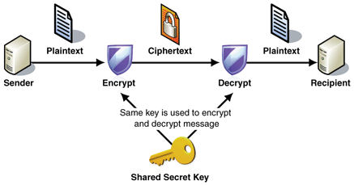

**Fig 1: Symmetric Encryption**

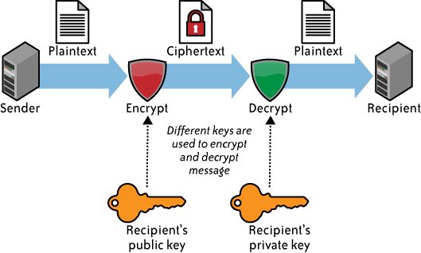

**Fig 2: Asymmetric Encryption**

**Bucket Cryption Mechanism:**

Bucket Cryption is a Symmetric cum Asymmetric cryptographic algorithm. It has a 64-bit [block size](https://en.wikipedia.org/wiki/Block_size_(cryptography)) and a variable [key length](https://en.wikipedia.org/wiki/Key_length) from 32 bits up to 448 bits. The unique aspect of this algorithm is that , the key has 2 parts- the 1st part is the IP address of the receiver and the 2nd part is the randomly generated 11 digit alphanumeric key. To successfully decrypt the content both the IP and the Secret key should match.

DATA

CIPHER DATA

Receiver IP Address

**FIG 3: Encryption Method**

CIPHER DATA

DATA

Current device IP Address

**FIG 4: Decryption Method**

**3.3.4 Password Mailing**

Every time the user logs in, the system generates a 11 digit random alphanumeric security key and sends it to the user email and updates the password. When the user logs in for the next time , the secret key should be entered correctly to ensure successful decryption.

**3.3.5 File uploading and downloading**

The ultimate goal of the system is to share files in LAN. So a user has the ability to upload a file and the file gets stored in the cloud. Then the receiver can download it by logging in the system. Bucket cryption is used to encrypt and decrypt the files in the cloud.

**CHAPTER 4 – IMPLEMENTATION**

**4. IMPLEMENTATION**

**4.1 Source code**

**4.2 Snapshots**

**4.2.1 Main Page**

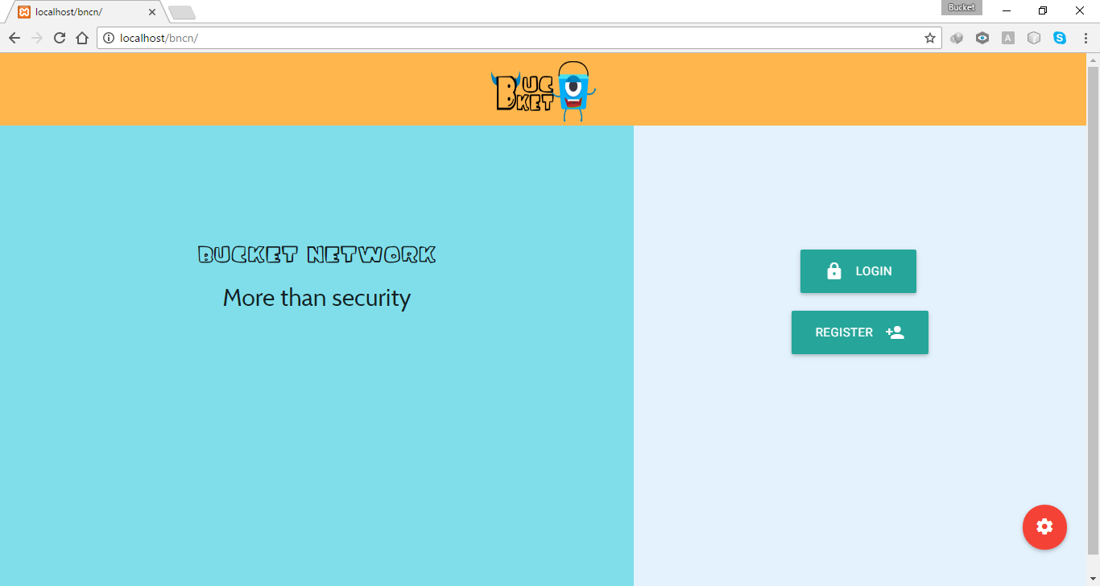

**4.2.2 Register page**

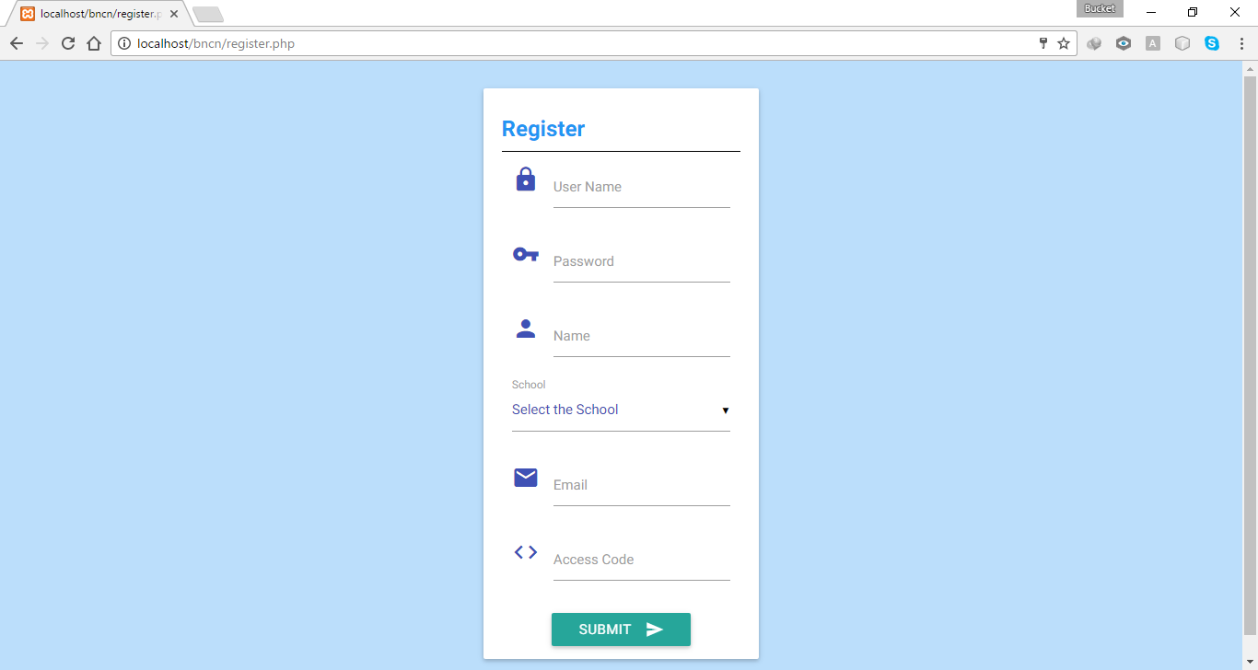

**4.2.3 Login Page**

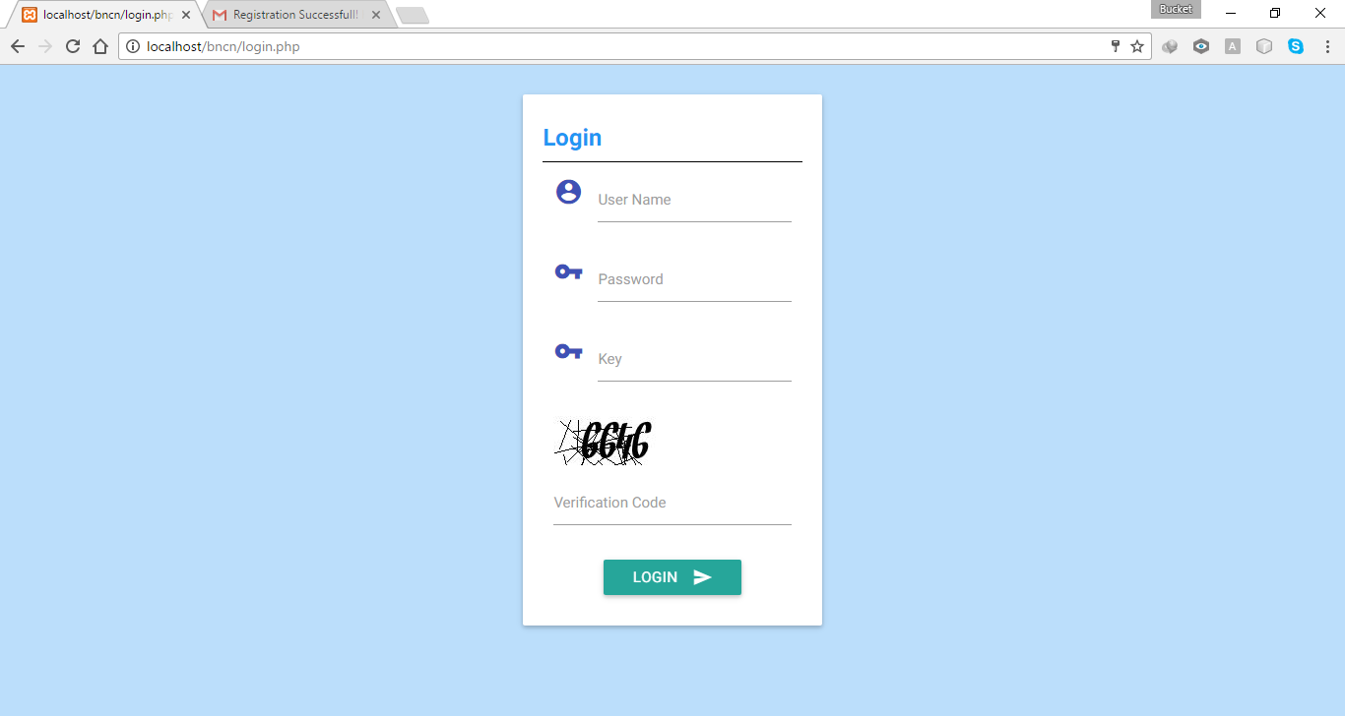

**4.2.4 Registration mail with Security Key**

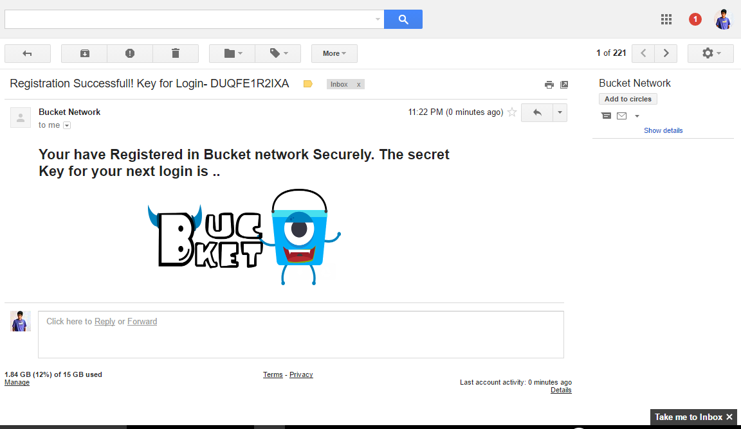

**4.2.5 Login Notification with Security Key**

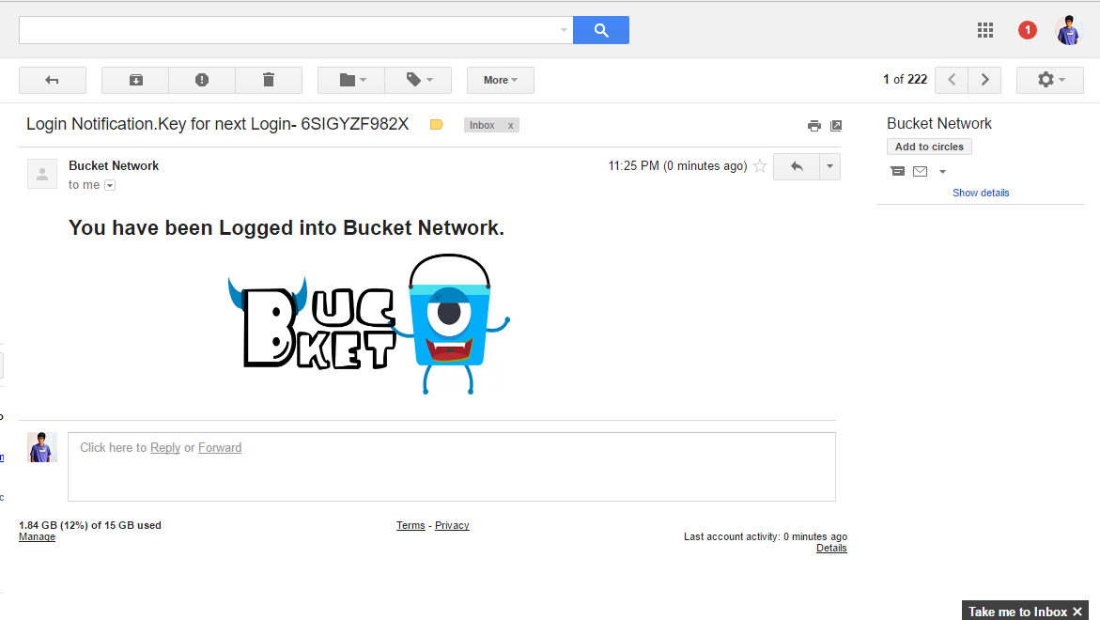

**4.2.6 Uploading and Viewing Page**

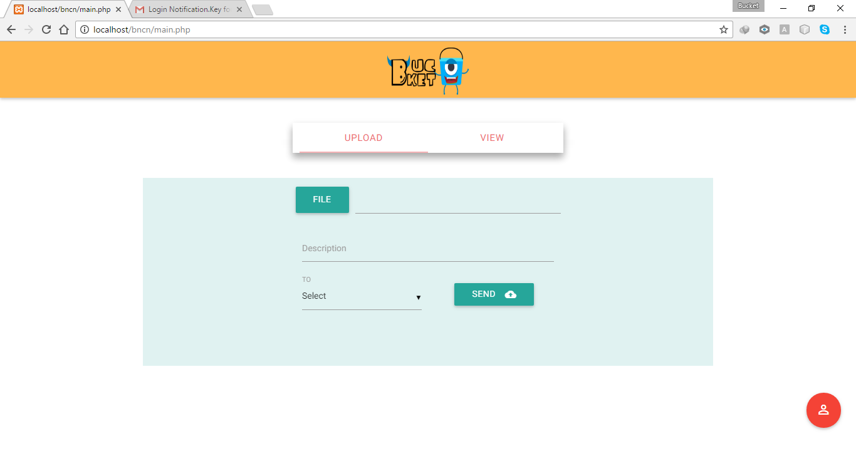

**CHAPTER – 5 RESULTS AND DISCUSSIONS**

**5. RESULTS AND DISCUSSIONS**

Bucket Network has been successfully deployed in LAN and can be accessed via a PC or phone. File sharing has been done successfully with the expected security level. The web application has been elegantly designed using Bootstrap CSS framework with all new latest technologies. The performance lag is negligible and it outperforms all the existing systems.

**CHAPTER 6 – CONCLUSION AND FUTURE WORK**

**6. Conclusion and Future work**

**6.1 Conclusion**

This project contains the implementation of secure file transfer between any two devices in a LAN. The project also focuses on a newly developed Bucket Cryption Algorithm. There has been a lot of issues in developing the application. Bucket Network is efficient, robust and scalable when compared to existing systems. File sharing is made easy and secure. Data traffic is bidirectional with android phones and personal computers. The overall project has been developed under open source technologies such as PHP and Bootstrap.

**6.2 Future work**

The application will be extended to transfer messages within the LAN. Also the project will be extended in future in such a way that it enables users to transfer files of considerably large size. Though the file is shared in distributed environment, the limitation over file size exists in the current version of the project and likely to be improved in future. The user interface could also be improved with latest and still more efficient frontend programming standards in order to eliminate the negligible performance lag in the current implementation.

**REFERENCES**

1. [https://www.**tutorialspoint**.com/**php**/](https://www.tutorialspoint.com/php/)
2. [https://en.wikipedia.org/wiki/**Blowfish**_(cipher)](https://en.wikipedia.org/wiki/Blowfish_(cipher))
3. [https://en.wikipedia.org/wiki/**RSA**_(cryptosystem)](https://en.wikipedia.org/wiki/RSA_(cryptosystem))
4. get**bootstrap**.com/getting-started/
5. www.w3schools.com/**jquery**/